**Report**

Enterprise Architecture

Index

2 Introduction 3

3 Business structures 4

3.1 Enterprise architectures 4

3.2 Architecture views 4

3.3 Viewpoints 4

3.3.1 Complexities 4

3.3.2 Organization viewpoint 5

3.3.3 Product viewpoint 5

3.3.4 Information structure viewpoint 6

3.3.5 Process viewpoint 7

3.3.6 Process Co-operation viewpoint 7

4 Software applications and infrastructure 9

4.1 Application co-operation viewpoint 9

4.2 application usage viewpoint 9

4.3 infrastructure viewpoint 10

4.4 implementation and deployment viewpoint 11

# Introduction

Here, the subject of enterprise architectures is reported.

The source of information shown are a few online sources, but mostly the provided material by the Fontys software engineering course.

# Business structures

## Enterprise architectures

Enterprise architecture is documentation that describes the structure and behavior of an enterprise, including its information systems. Additionally, it is planning and governing changes to improve the integrity and flexibility of the enterprise.

## Architecture views

An architecture view is a representation of the overall architecture that contains information relevant for one or more stakeholders. The perspective from which the view is taken is called a viewpoint.

Enterprises can be extremely complex, so it is divided up into less complex views. These can be in different levels of detail, called aggregation levels.

Higher aggregation levels are easier to understand and grasp but less informative, while lower aggregation levels are more complex, perhaps even depicted in several diagrams, but more informative.

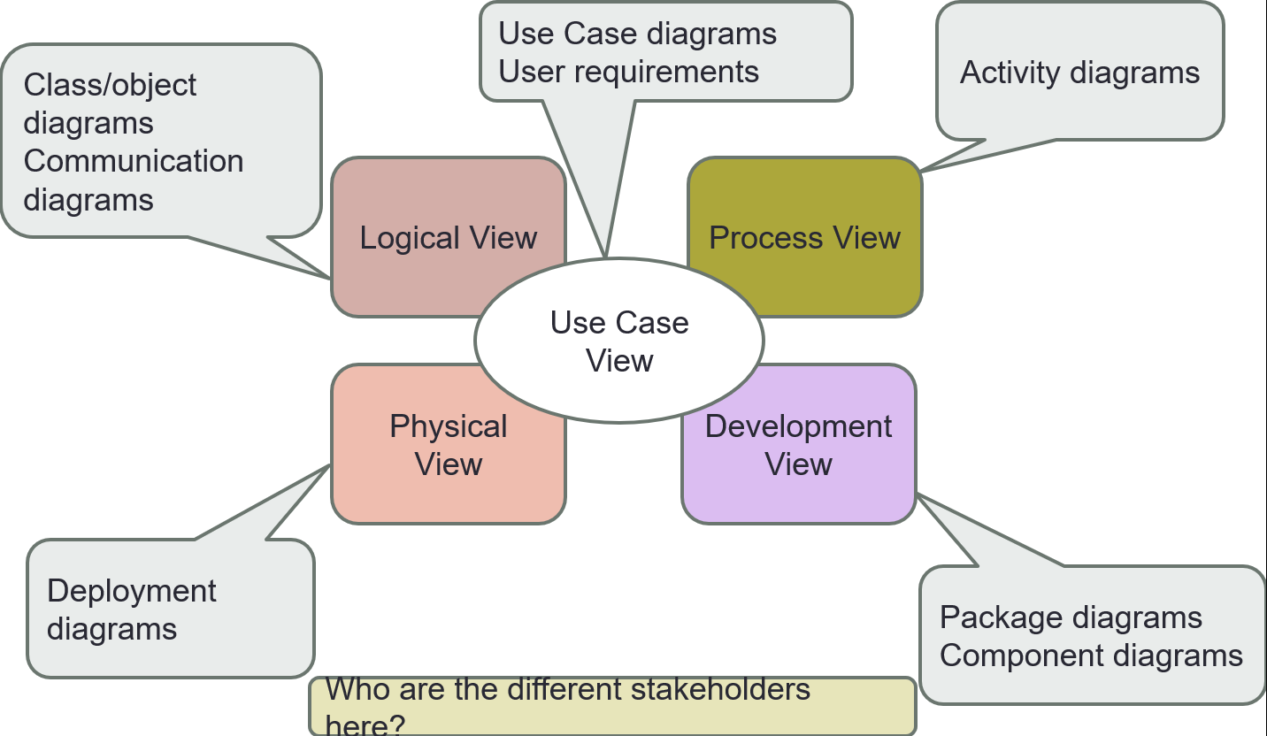

## Viewpoints

### Complexities

Viewpoints can have multiple complexities: basic, semi-complex, and complex.

The complexity of a viewpoint is defined by the scope.

### Organization viewpoint

The organization viewpoint focuses on the internal organization of the company or department. The stakeholders here are the enterprise, process and domain architects, managers, employees, and shareholders.

#### Business Role

Behavior, to which an actor can be assigned, and uses the association relationship.

#### Business Actor

An organization entity – humans, departments, and business units – and uses the aggregation, composition, or association relationship.

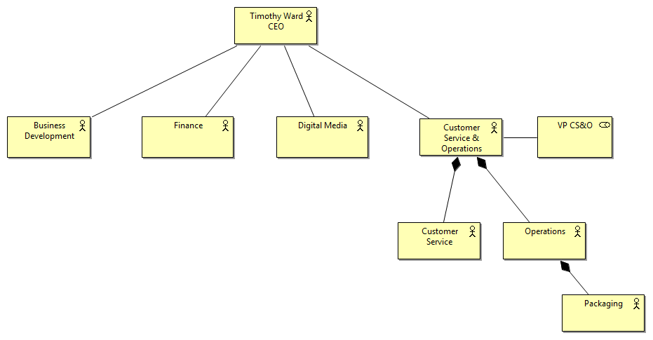

### Product viewpoint

The product viewpoint depicts the products offered to the customers or other external parties involved and shows the composition of one or more products in terms of the constituting business services.

#### Product

A coherent collection of services offered to the client as package, uses the aggregation and specialization relation.

#### Service

A service that fulfills a business need for a customer, also uses the aggregation and specialization relation.

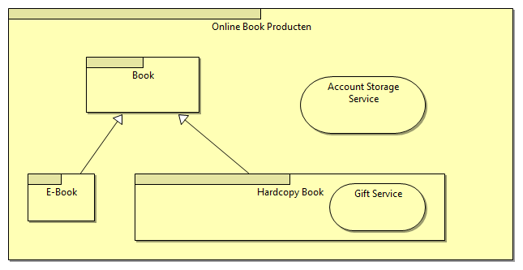

### Information structure viewpoint

The information models created in software design. It shows the structure of the information used in the enterprise.

The stakeholders here are the domain and information architects.

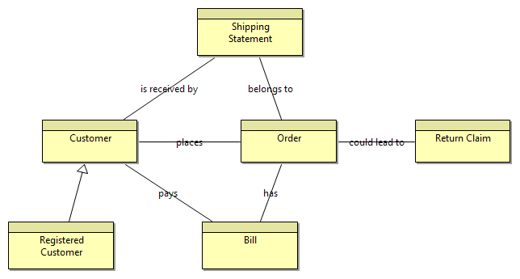

### Process viewpoint

The business process shows the high-level structure and composition of business process, and the relation with services that a business process offers to the outside world – showing how a process contributes to the realization of the company’s products.

The stakeholders here are the process and domain architects and operational managers.

#### Business service

Realization of a process, which uses the realization relationship.

#### Business event

Something that happens and may influence business processes, which uses the triggers relationship.

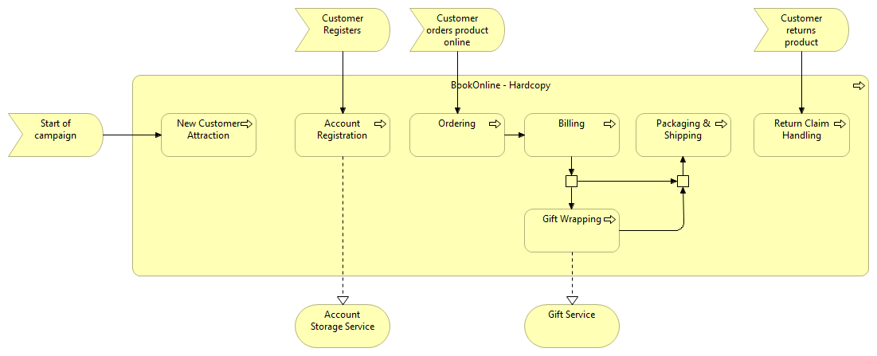

### Process Co-operation viewpoint

The business process co-operation viewpoint shows the assignment of business processes to roles, which gives insight into the responsibilities of the associated actors, and the information used by the business process.

The stakeholders here are the process and domain architects, and the operational managers.

#### Roles or actors

Person who may/must perform it.

#### Business object

Object accessed by a process, which uses the access relationship.

#### Business actor or role

The performer of the process.

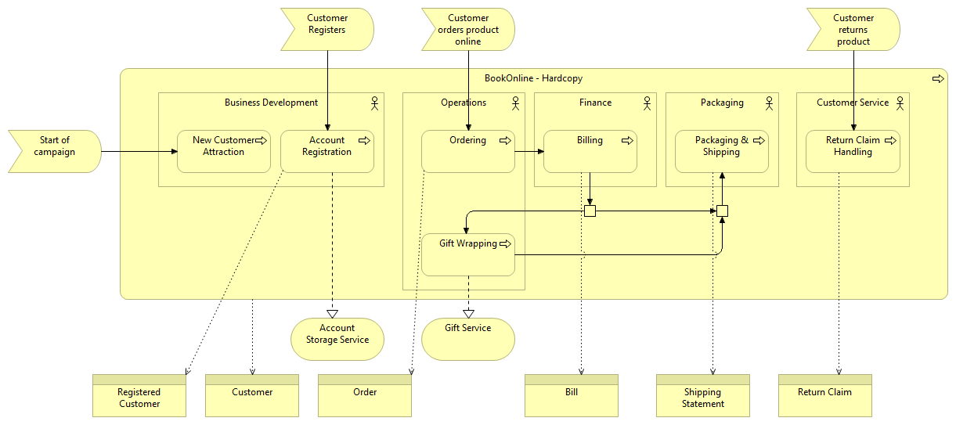

# Software applications and infrastructure

## Application co-operation viewpoint

The application co-operation viewpoint describes the relationships between applications components in term of the information flows between them, or in terms of the services they offer and use.

This viewpoint is typically used to create an overview of the application landscape of an organization.

#### Application

A software system, which uses the used by relationship.

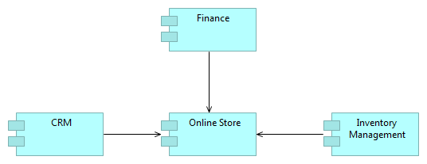

## application usage viewpoint

The application usage viewpoint describes how applications are used to support one or more business processes. It can be used in designing an application by identifying the services needed by business processes and other applications, or in designing business processes by describing the services that are available.

The stakeholders here are the enterprise, process and application architects, and operation managers.

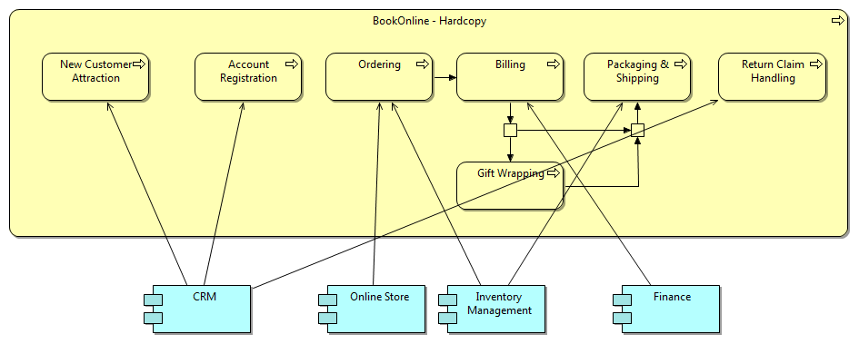

## infrastructure viewpoint

The Infrastructure viewpoint contains the software and hardware infrastructure elements supporting the application layer, such as physical devices, networks, or system software.

The stakeholders here are the infrastructure architects and operational managers.

#### Node

A computational resource where artifacts may be stored or deployed for execution. A nod is often a combination of a hardware device and system software, e.g. application servers, database servers, and client workstations.

#### System software

A software environment for component and objects.

#### Device

Hardware resource upon which artifacts may be stored or deployed, e.g. mainframes, PCs, or routers.

#### Network

A communication medium between two or more devices.

#### Artifact

A physical piece of data that is used or produced in a software development process, or by deployment and operation of a system.

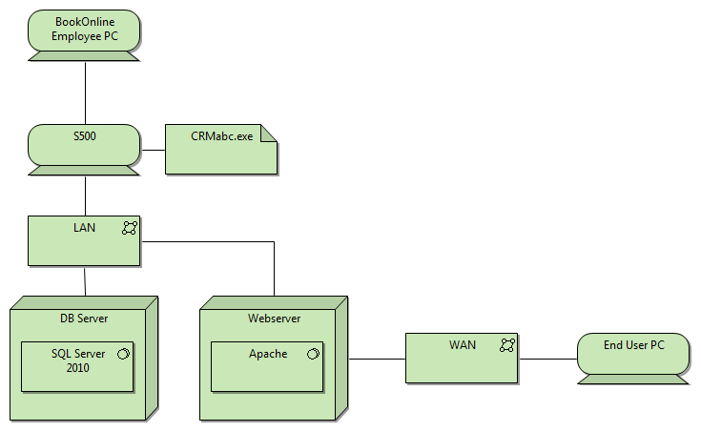

## implementation and deployment viewpoint

The Implementation and Deployment viewpoint shows how one or more applications are realized on the infrastructure. This comprises the mapping of (logical) applications and components onto (physical) artifacts.

The stakeholders here are the application and infrastructure architects, and the operation managers.

